Demo reproducible workflow template document

Abstract
As of today (May 02, 2025), we have gathered 150 across 3.
Table 1: Summary statistics
Species | Sepal Length  mean (SD) | Sepal Width  mean (SD) | Petal Length  mean (SD) | Petal Width  mean (SD)
Setosa | 5 (0.4) | 3.4 (0.4) | 1.5 (0.2) | 0.2 (0.1)
Versicolor | 5.9 (0.5) | 2.8 (0.3) | 4.3 (0.5) | 1.3 (0.2)
Virginica | 6.6 (0.6) | 3 (0.3) | 5.6 (0.6) | 2 (0.3)
Table 1 shows the descriptive means and standard deviations of sepal and petal lengths and widths for each species
Figure 1: Pedal widths and lengths
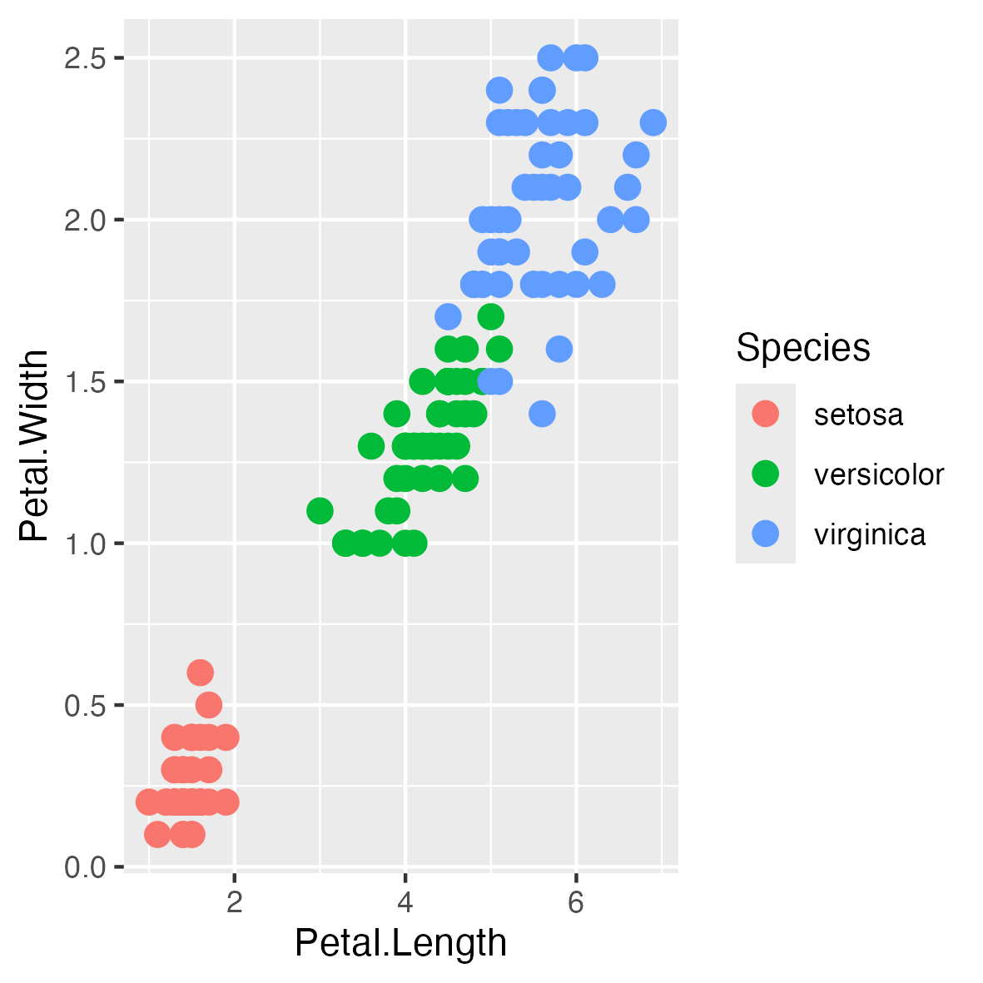
As shown in figure 1, we find that each additional 1 mm difference in petal width is associated with an additional 2.2mms (95%CI: 2.12837524603662:2.3315057442071) of pedal length.

